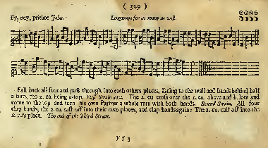

Fy, Nay, Prithee John. Dance Steps from Playford ‘The Dancing Master’ 174 edn. (above) and 1703 edn. (below)

A 1 All fall back a double

2-3 Forward and pass partners R shoulder and give hands to form back ring

4 circle half way to R and turn towards partner and face in.

B 1-2 @nd C cross, go below, cross and back to top

3-4 place and turn 2 hands once.

C 1 All clap hands 4 times

2 2nd C cast down, 1st C lead up

3-4 All clap again, 1st C cast down, 2nd C lead up.